REG NO: 22TD0006 NAME: ARUL SHRINIVAS A YEAR/SEM/SEC: Y3/S5/B
PREDEFINED EXCEPTION

PROGRAM:

SQL>set serveroutput on;
declare
empid number(8);
emname varchar(10);
begin
empid:=&empid;
select empname into from employe where empno=empid;
dbms_output.put_line(‘The empoye name is:’||emname);
exception
when no_data_found then
dbms_output.put_line(‘data not found’);
end;
/

OUTPUT:

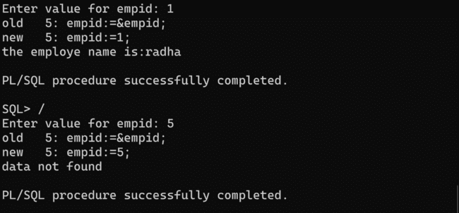

REG NO: 22TD0006 NAME: ARUL SHRINIVAS A YEAR/SEM/SEC: Y3/S5/B

USER DEFINED EXCEPTION

PROGRAM:

SQL> set serveroutput on;
declare
co number;
exceeds_value exception;
begin
select count(*)into co from bankgrd;
if co<5 then
insert into BANK values(&s_no,’&cust_name’,&balance);
else
raise exceeds_value;
end if;
exception
when exceeds_value then
dbms_output.put_line(‘row will not be inserted’);
end;
/

OUTPUT:

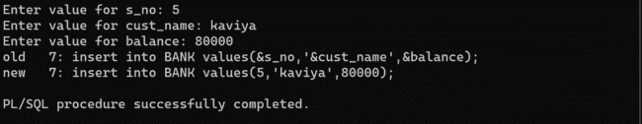
REG NO: 22TD0006 NAME: ARUL SHRINIVAS A YEAR/SEM/SEC: Y3/S5/B

DATA DEFINITION LANGUAGE

CREATE TABLE COMMAND
Syntax:
SQL> Create table<table name>(fieldname1 datatype1(size),fieldname2 datatype2(size)….fieldname n datatype n(size));

Query:

Created table:
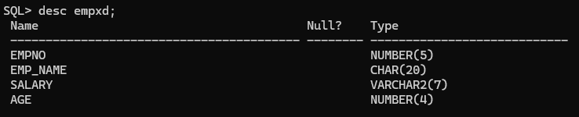
ALTER COMMAND
The Alter command is associated with the following commands
- ADD
- MODIFY
- DROP

USES OF ALTER COMMANDS
- We can add a new field in an already created table
- We can change the data type and size in a already created table
- We can add integrity constraints to a field
- We can drop integrity constraints of a field
- We can drop a field (or) column from a table

ADD FIELD
Syntax:
SQL>alter table<table_name>add (fieldname1 datatype1(size)….fieldname n
datatype n(size));
Query:
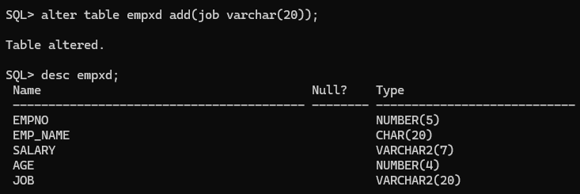

MODIFY FIELD
Syntax:

SQL>altertable<table_name>modify (fieldname1 datatype1(size)……fieldname n datatype n(size));
Query:
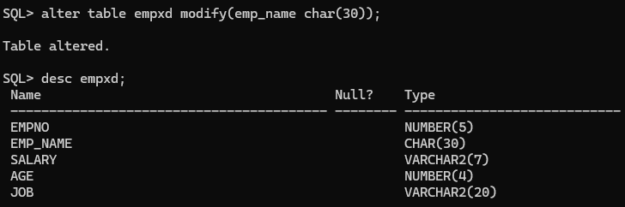

DROP FIELD
Syntax:
SQL> alter table<table_name>drop<column_name>;

Query:

TRUNCATE TABLE
Syntax:
SQL> truncate table<table_name>;

Query:

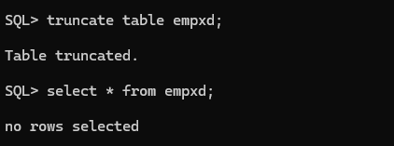

RENAME TABLE

Syntax:
SQL>rename<table_name> to <new_table_name>;

Query:
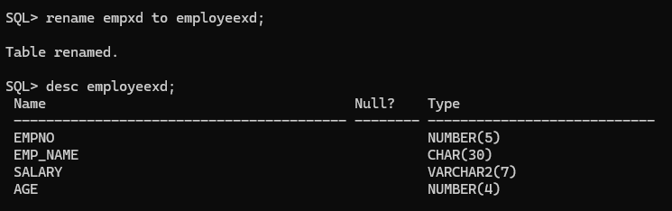

DROP TABLE COMMAD
Syntax:
SQL> drop table<table_name>;

Query:

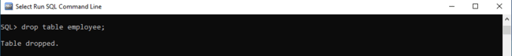

After drop the table will not be present,

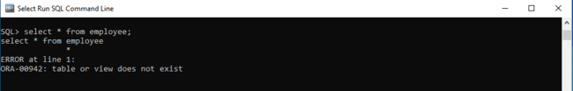

REG NO: 22TD0006 NAME: ARUL SHRINIVAS A YEAR/SEM/SEC: Y3/S5/B

DATA MANIPULATION LANGUAGE

INSERT

Syntax:
SQL> insert into <table_name> values<value1,value2….value n>;

Query:
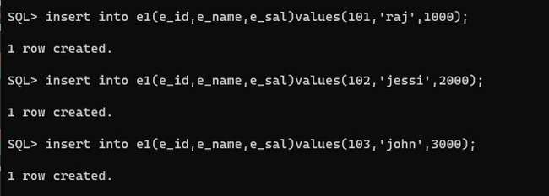

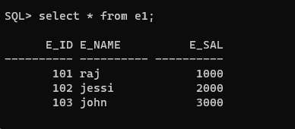

UPDATE

Syntax:
SQL> update<table_name> set field_name=<expression>where [condition];

Query:
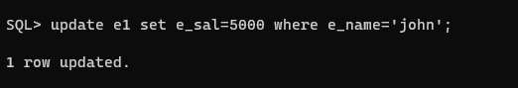

DELETE

Syntax:
SQL> delete from <table_name>where [condition];

Query:

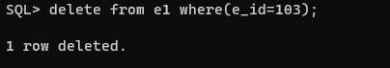

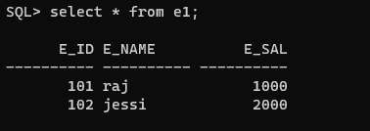

REG NO: 22TD0006 NAME: ARUL SHRINIVAS A YEAR/SEM/SEC: Y3/S5/B

DATA QUERY LANGUAGE

CREATE TABLE employe1:
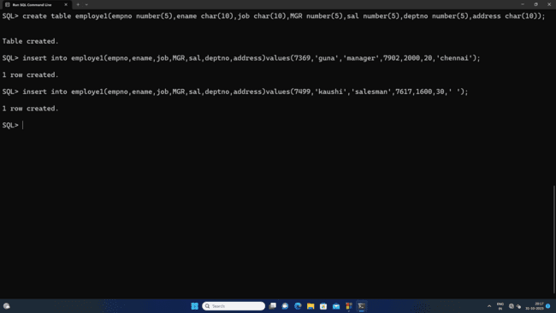

TABLE STRUCTURE:
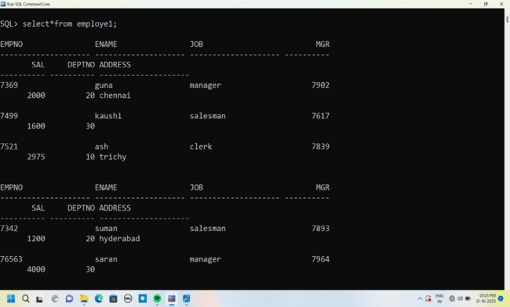

SELECT
Syntax:
SQL>select <column_name>from<table_name>where[condition];

Query:
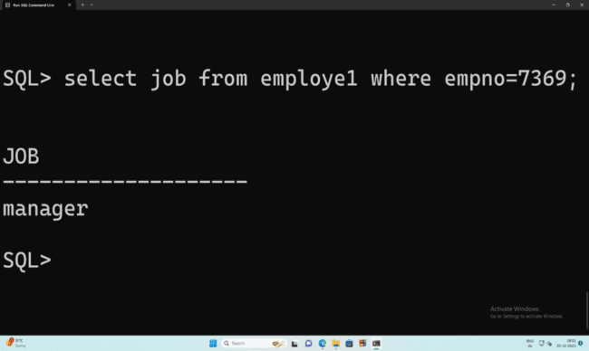

ORDER BY
- ASCENDING:
Syntax:
SQL>select<column_name>from<table_name>order by<column_name>;
Query:
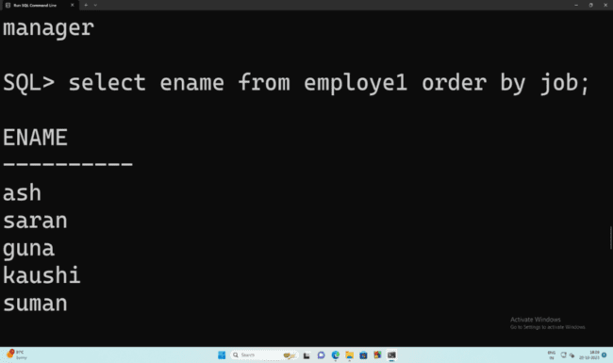

- DESCENDING:
Syntax:
SQL>select<column_name>from<table_name>order by<column_name>desc;
Query:
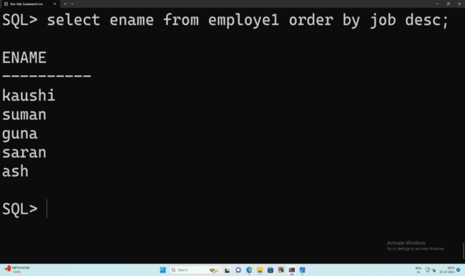

GROUP BY
Syntax:
SQL>select<column_name>from<table_name>order by<column_name>;
Query:
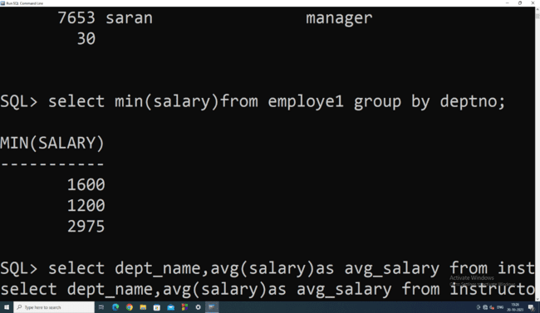

HAVING CLAUSE
Syntax:
SQL>select<column_name>from<table_name>where[condition]group by column having[condition];
Query:
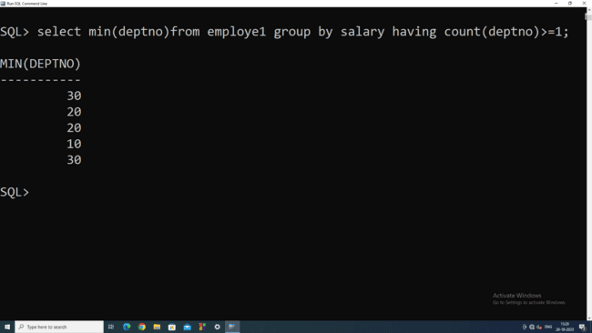

NULL
Syntax:
SQL>select<column_name>from<table_name>where<column_name>is null;
SQL>select<column_name>from<table_name>where<column_name>is not null;
Query:
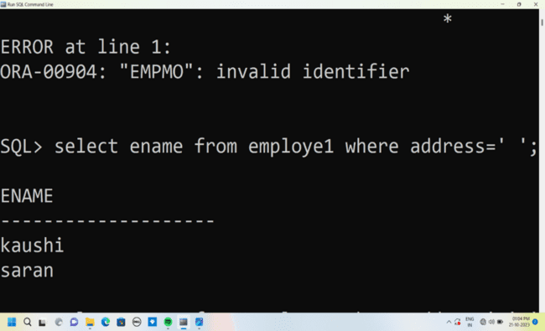

REG NO: 22TD0006 NAME: ARUL SHRINIVAS A YEAR/SEM/SEC: Y3/S5/B

DATA CONTROL LANGUAGE

CREATE TABLE employee1 AND employee2:
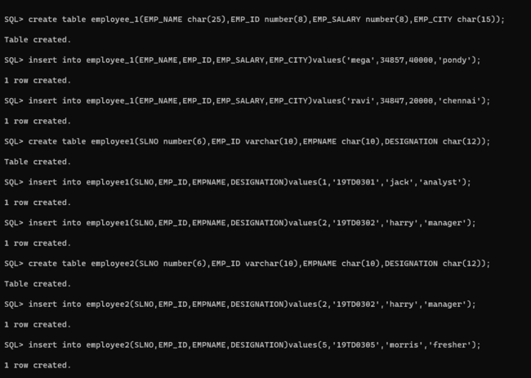


TABLE STRUCTURE:
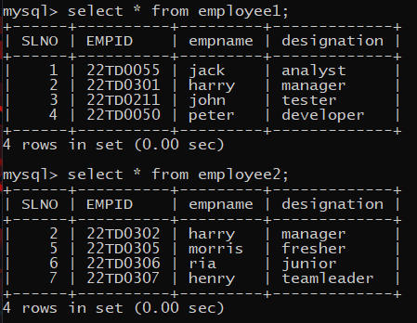

COMMIT
Syntax:
SQL> commit;

Query:
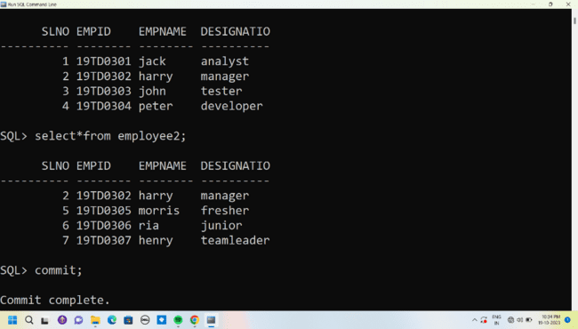

SAVEPOINT
Syntax:
SQL> savepoint <name>;

Query:
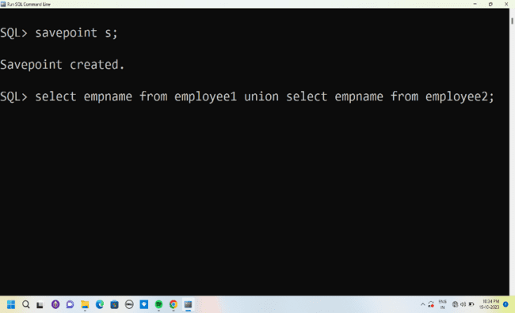

ROLLBACK

Syntax:
SQL> rollback;

Query:

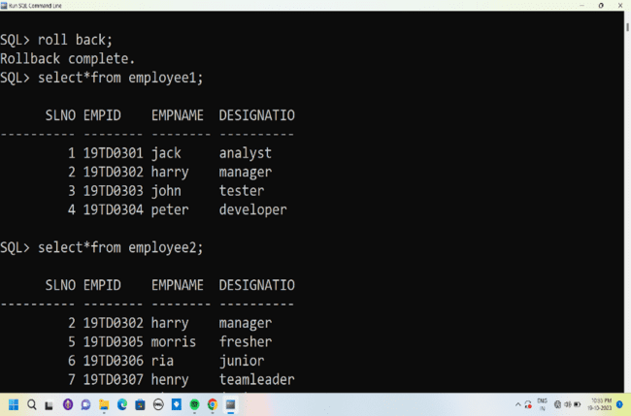

GRANT
Syntax:
SQL>grant<select> on <table_name>to user;
Query:
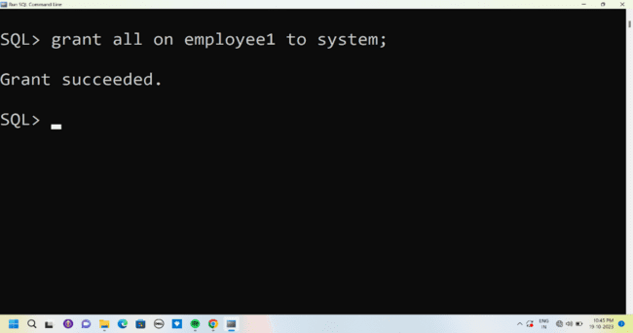

UNION
Syntax:
SQL>select<column_name>from<table_name>union select <column_name>from<table_name>;
Query:
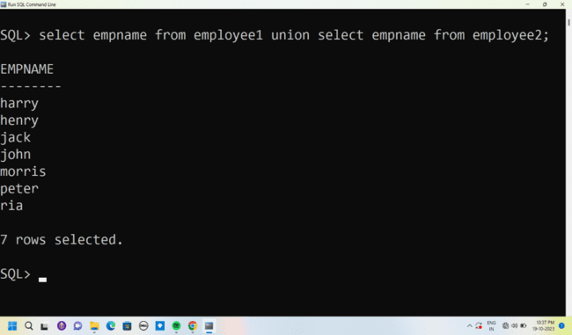

UNIONALL
Syntax:
SQL> select<column_name>from<table_name>unionall select <column_name>from<table_name>;
Query:
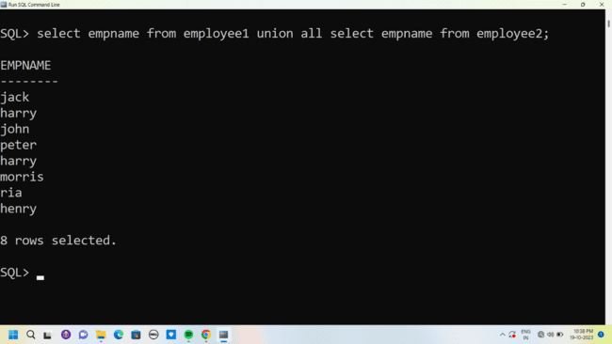

INTERSECT
Syntax:
SQL> select<column_name>from<table_name>intersect select <column_name>from<table_name>;
Query:
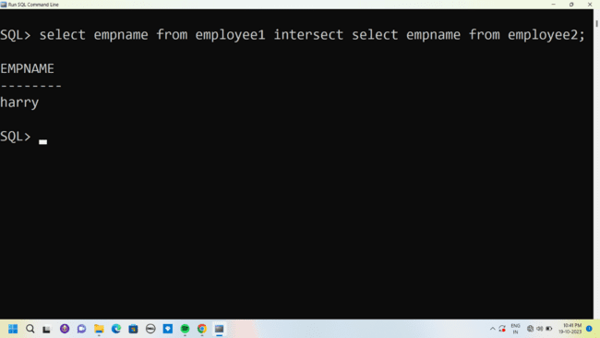

MINUS
Syntax:
SQL> select<column_name>from<table_name>minus select <column_name>from<table_name>;

Query:
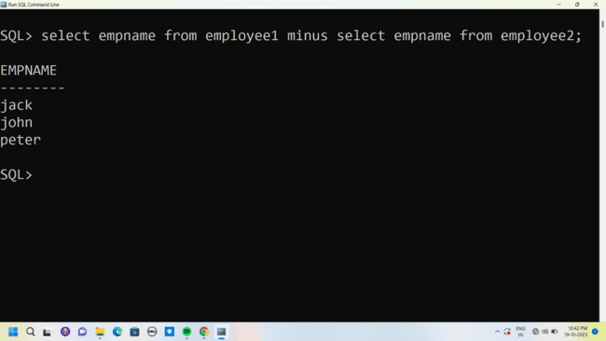

REG NO: 22TD0006 NAME: ARUL SHRINIVAS A YEAR/SEM/SEC: Y3/S5/B

SET OPERATIONS
CREATE TABLE employee AND department:
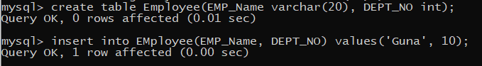
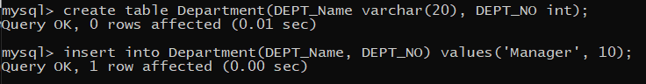
TABLE STRUCTURE:
Table 1: Employee
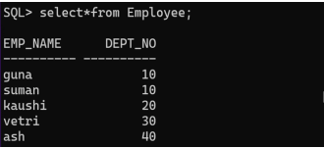
Table 2: Department
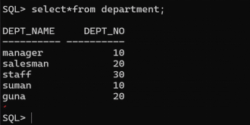
UNION:
Syntax:
SQL> select <column_name> from<table_name> union select
<column_name>from<table_name>;
Query:
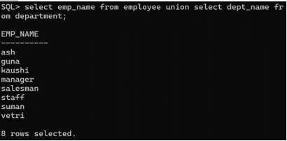
UNION ALL:
Syntax:
SQL> select <column_name> from<table_name> union all
select<column_name>from<table_name>;
Query:
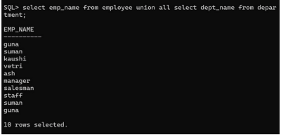

INTERSECTION:
Syntax:
SQL> select <column_name> from<table_name> intersect
select<column_name>from<table_name>;

Query:
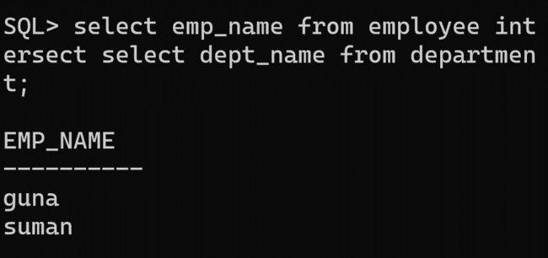
MINUS:
Syntax:
SQL> select <column_name> from<table_name> minus
select<column_name>from<table_name>;

Query:
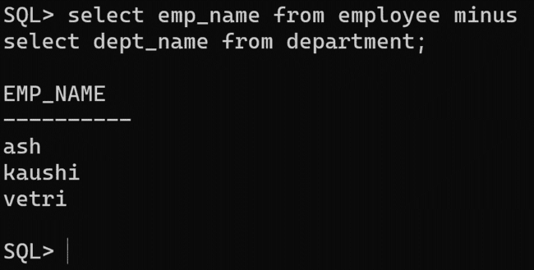

CREATE TABLE employee_1:

TABLE STRUCTURE:
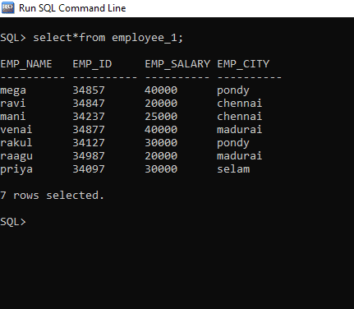

BETWEEN:
Syntax:
SQL>select <column_name>from<table_name>where<column_name> BETWEEN value1 AND value2;
Query:
- List all the employee detail with salary in the range 20000 and 30000;
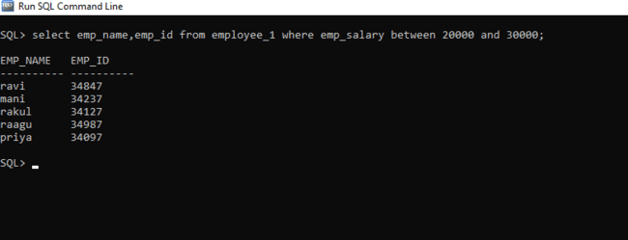

NOT BETWEEN:
Syntax:
SQL>select<column_name>from<table_name>where<field_name>NOT BETWEEN value1 AND value2;
Query:
- List all the employee detail with salary not in the range 20000 and 30000;
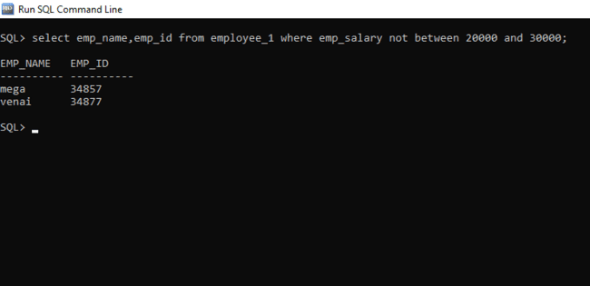

IN:
Syntax:
SQL>select <column_name>from <table_name>WHERE<column_name>IN (value1,value2,…value n);
Query:
- List the employee detail whose city in pondy and chennai;
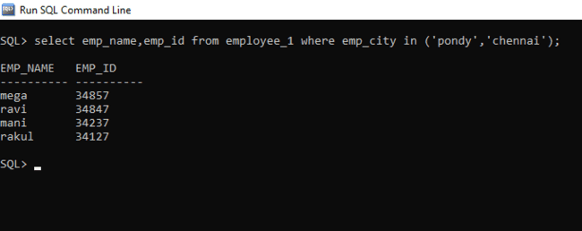

NOT IN:
Syntax:
SQL>select <column_name>from<table_name>WHERE<field_name> NOT IN [condition];

Query:
- List the employee detail whose pondy not in chennai;

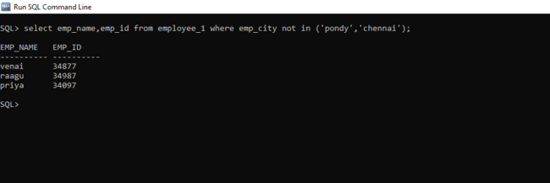

REG NO: 22TD0006 NAME: ARUL SHRINIVAS A YEAR/SEM/SEC: Y3/S5/B
JOINS
- Inner Join

        - Equi Join
        - Non-Equi Join
        - Natural Join
- Outer Join
        - Left Outer Join
        - Right Outer Join
        - Full Outer Join
CREATE TABLE stu AND dept:

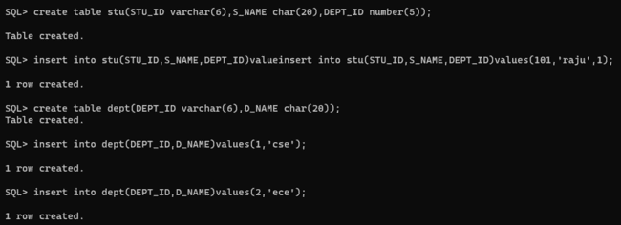
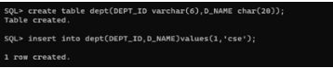
TABLE STRUCTURE:
Table 1: stu
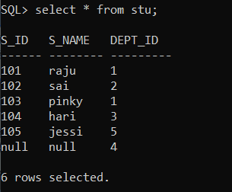

Table 2: dept
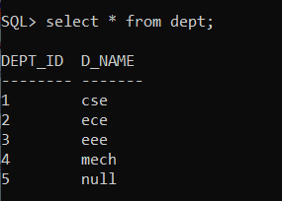
INNER JOIN
EQUI JOIN:
Syntax:
SQL>select <column_name> from <table_name> where [condition];
Query:
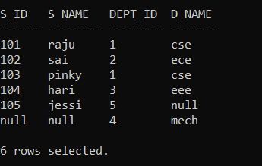

NON-EQUI JOIN:
Syntax:
SQL>select <column_name> from <table_name> where [condition];
Query:
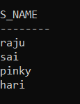
SELF JOIN:
Syntax:
SQL>select <column_name> from <table_name> where [condition];
Query:
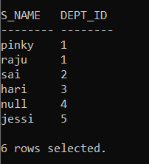

OUTER JOIN:
LEFT OUTER JOIN:
Syntax:
SQL>select <column_name> from <table 1> left outer join <table 2> on [condition];
Query:
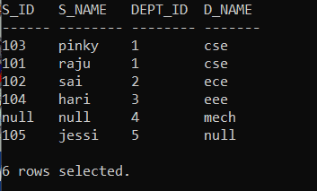
RIGHT OUTER JOIN:
Syntax:
SQL>select <column_name> from <table 1> right outer join <table 2> on [condition];
Query:
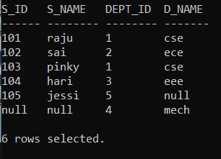

FULL OUTER JOIN:
Syntax:
SQL>select <column_name> from <table 1> full outer join <table 2> on [condition]

Query:
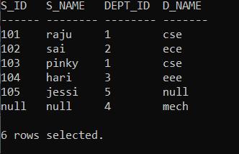
CARTESIAN JOIN:

Syntax:

SQL>select table1.column1,table2.column2 from table1,table2;

Query:
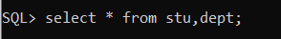

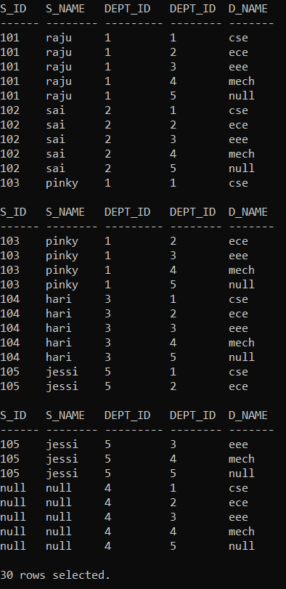

REG NO: 22TD0006 NAME: ARUL SHRINIVAS A YEAR/SEM/SEC: Y3/S5/B
VIEWS
CREATE TABLE student:
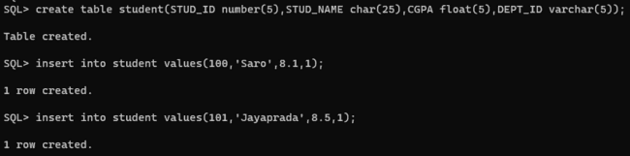
TABLE STRUCTURE:
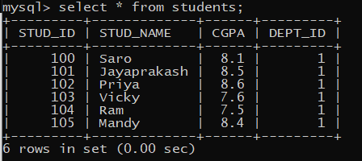
CREATING VIEWS
Syntax:
SQL>create view <view name> as select column1, column2...column n from <table name> where [condition];
Query:
View is created for the table,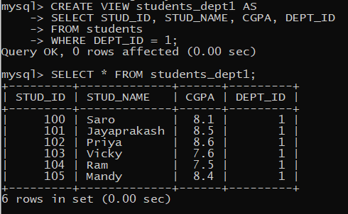

INSERT:
Syntax:
SQL>insert into <view_name>(fieldname1,fieldname2….filedname n)values(value1,value2….value n);

Query:

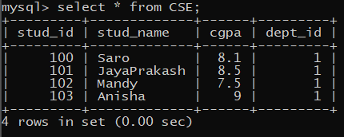

Table after inserting in view,
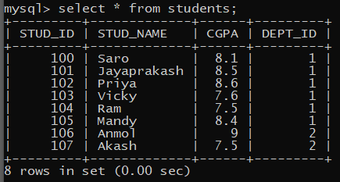

UPDATING A VIEW:
Syntax:
SQL>update <view_name> where [condition];
Query:
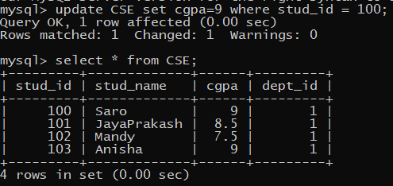

Table after updating the view,
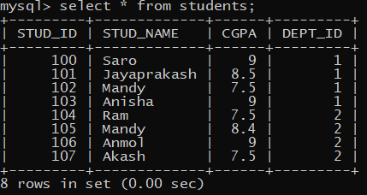

DELETE:

Syntax:

SQL> delete from <view_name> where [condition];

Query:
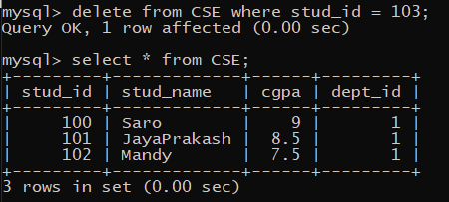
Table after deleting in view,
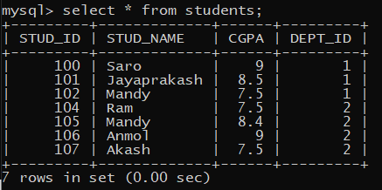

DROP:

Syntax:
SQL>drop view<view_name>;

Query:
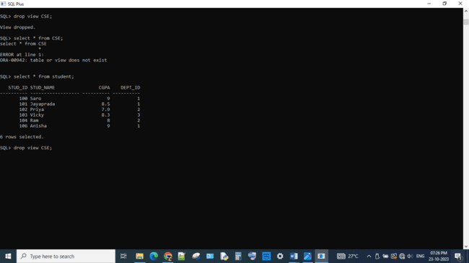

After the view is dropped the table will be remind the same,
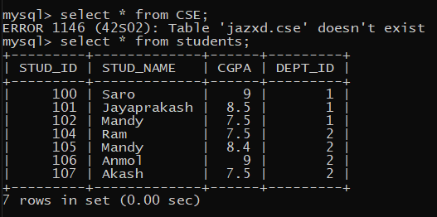

REG NO: 22TD0006 NAME: ARUL SHRINIVAS A YEAR/SEM/SEC: Y3/S5/B

SUB QUERIES

CREATE TABLE student AND database:
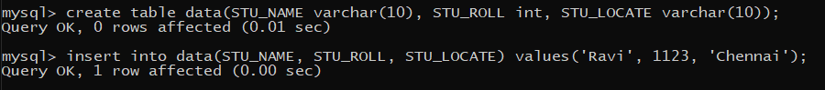
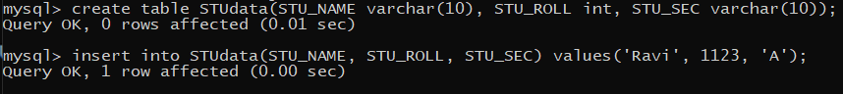

TABLE STRUCTURE:
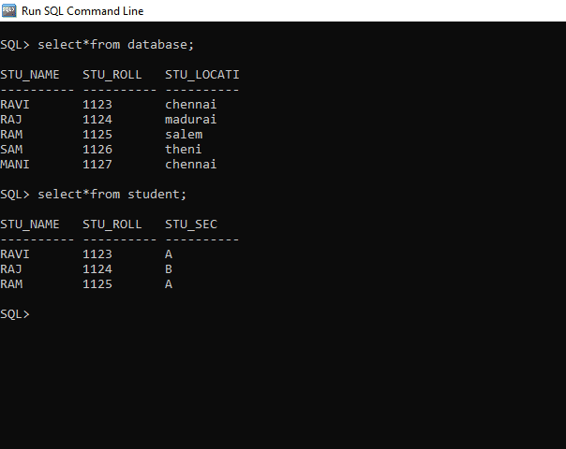

SELECT:

Syntax:

SQL> SELECT column_name

FROM table_name

WHERE column_name expression operator

( SELECT column_name from table_name WHERE ... );

Query: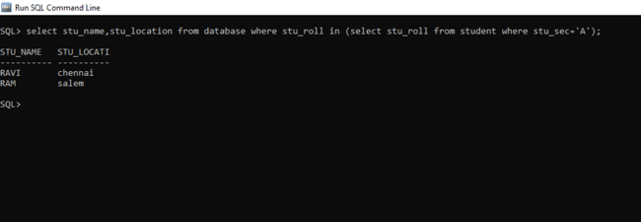

INSERT

Syntax:

SQL> INSERT INTO table_name (column1, column2, column3....)

SELECT *

FROM table_name

WHERE VALUE OPERATOR

Query:
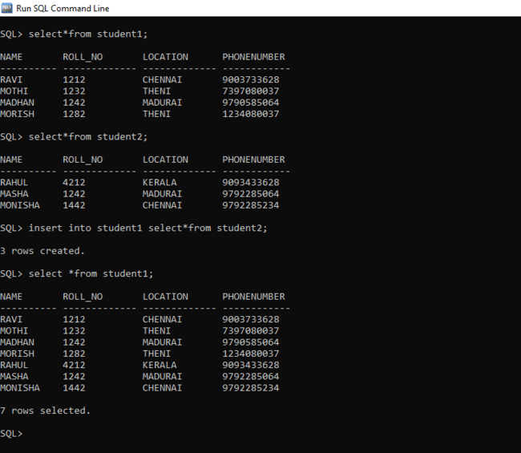

DELETE:

Syntax:

SQL>DELETE FROM TABLE_NAME

WHERE VALUE OPERATOR

(SELECT COLUMN_NAME

FROM TABLE_NAME

WHERE condition);

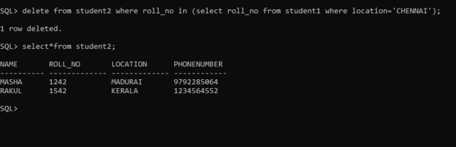

UPDATE

Syntax:
SQL> UPDATE table
SET column_name = new_value
WHERE VALUE OPERATOR
(SELECT COLUMN_NAME
FROM TABLE_NAME
WHERE condition);
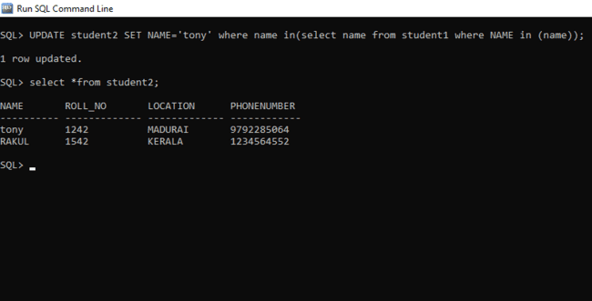

REG NO: 22TD0006 NAME: ARUL SHRINIVAS A YEAR/SEM/SEC: Y3/S5/B

ADDITION OF TWO NUMBERS

PROGRAM:
SQL>set serveroutput on;
declare
x integer;
y integer;
z integer;
begin
x:=&x;
y:=&y;
z:=x+y;
dbms_output.put_line(‘The sum of two numbers is’||z);
end;
/

REG NO: 22TD0006 NAME: ARUL SHRINIVAS A YEAR/SEM/SEC: Y3/S5/B

FACTORIAL OF A NUMBER

PROGRAM:
SQL> set serveroutput on;
declare
f number:=1;
i number;
n number:=&n;
begin
for i in 1..n
loop
f:=f*i;
end loop;
dbms_output.put_line(‘the factorial of given number is:’||f);
end;
/

REG NO: 22TD0006 NAME: ARUL SHRINIVAS A YEAR/SEM/SEC: Y3/S5/B

SUM OF SERIES

PROGRAM:
SQL> set serveroutput on;
declare
n number:=&n;
i number;
begin
i:=n*(n+1);
n:=i/2;
dbms_output.put_line(‘the sum of series of given number is:’||n);
end;
/

REG NO: 22TD0006 NAME: ARUL SHRINIVAS A YEAR/SEM/SEC: Y3/S5/B

FIBONACCI SERIES

PROGRAM:
SQL>set serveroutput on;
declare
i number;
c number;
n number:=&n;
a number:=-1;
b number:=1;
begin
for i in 1..n
loop
c:=a+b;
dbms_output.put_line(c);
a:=b;
b:=c;
end loop;
end;
/

REG NO: 22TD0006 NAME: ARUL SHRINIVAS A YEAR/SEM/SEC: Y3/S5/B

PALINDROME SERIES

PROGRAM:
SQL>set serveroutput on;
declare
len number;
a integer;
str1 varchar(10):=’&str1’;
str2 varchar(10);
begin
len:=length(str1);
a:=len;
for i in 1..a
loop
str2:=str2||substr(str1,len,1);
len:=len-1;
end loop;
if(str1=str2)then
dbms_output.put_line(str1||’ is a palindrome’);
else
dbms_output.put_line(str1||’ is not a palindrome’);
end if;
end;
/

REG NO: 22TD0006 NAME: ARUL SHRINIVAS A YEAR/SEM/SEC: Y3/S5/B

PACKAGES

SOURCE CODE:
PACKAGE EXCEPTION:
create or replace package packs is
procedure display;
function prime(n number) return varchar;
function odd(n number) return varchar;
function positive(n number)return varchar;
end packs;

PACKAGE BODY:
create or replace package body packs as
procedure display is
avarchar(15);
m number;
begin
m:=&m;
a:=prime(m);
if a=prime(m)then
dbms_output.put_line(m||'is a prime');
else
dbms_output.put_line(m||'is not prime');
end if;
a:=odd(m);
if a='odd' then
dbms_output.put_line(m||'is odd');
else
dbms_output.put_line(m||'is even');
end if;
a:=positive(m);
if a='positive' then
dbms_output.put_line(m||'is a positive number');
else
dbms_output.put_line(m||'is a negative number');
end if;
end display;
function prime(n number) return varchar is
i number;
flag number;
begin
flag:=0;
for i in 2..n/2
loop
if mod(n,i)=0 then
flag:=1
return 'not prime';
end if;
end loop;
if flag=0 then
return 'prime';
end if;
end prime;
function odd(n number) return varchar is
begin
if n>0 then
return 'positive';
else
return 'negative';
end if;
end positive;
end packs;

OUTPUT:
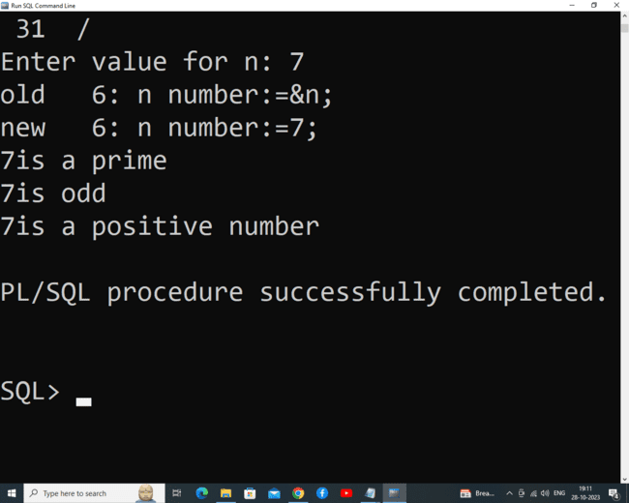

REG NO: 22TD0006 NAME: ARUL SHRINIVAS A YEAR/SEM/SEC: Y3/S5/B

CURSOR

SOURCE CODE:
DELETING THE RECORD USING CURSOR
SQL> declare
cursor c is select * from vechicle1;
a c % rowtype;
n number:=0;
begin
open c;
loop
fetch c into a;
exit when c% notfound;
ifa.vehicle_no=521 then
delete from vehicle1 where vehicle_no=521;
n:=n+1;
end if;
end loop;
dbms_output.put_line('deleted record'||n);
dbms_output.put_line('remaining records'||(c % rowcount-n));
close c;
commit;
end;
/

OUTPUT:
